Audio Sampling Activity using Audacity
Use audacity, record 30 seconds of your reading of an article or poem with the following settings and then compare and contrast the resulting files’ sound quality and file size.
a. mono, 8000Hz sampling rate, 16 bit depth;
b. mono, 44100Hz sampling rate, 16 bit depth;
c. stereo, 8000Hz sampling rate, 32 bit depth;
d. stereo, 44100hz sampling rate, 32 bit depth;
For each recording, export your project into a wav file, upload your wav file to your wiki page under projects.
Compare and contrast the four files you exported regarding sound quality and file size.
To change recording settings, open preferences interface:
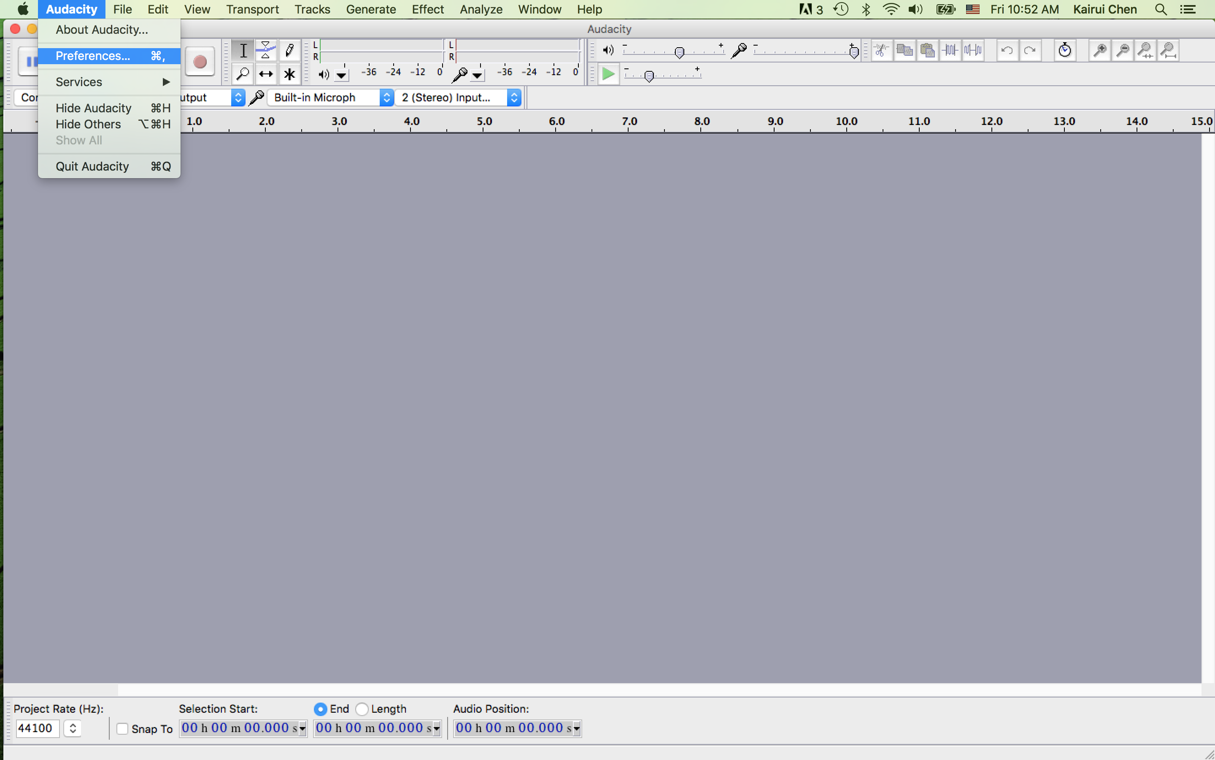
Then select “quality” to change the sampling rate and sample format (or quantization bit depth)
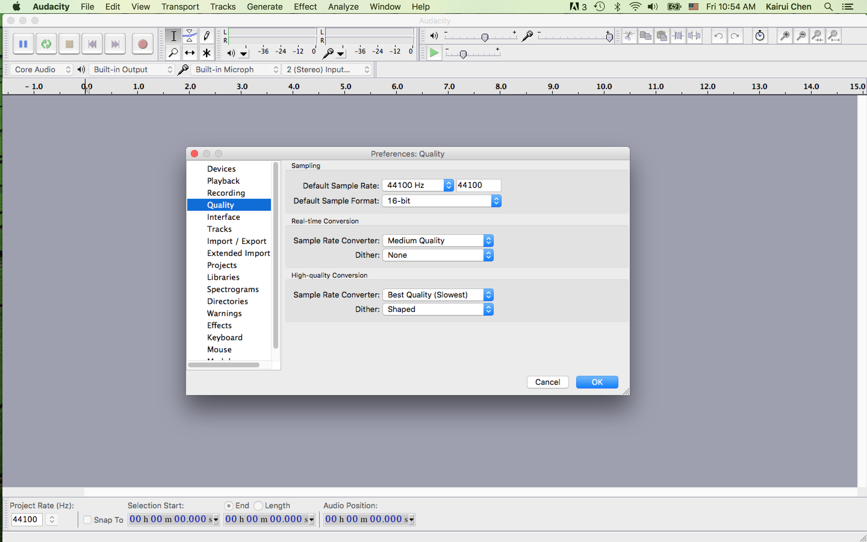

To choose between mono and stereo recording, go to “devices” tab under preferences interface and choose the right microphone device and number of channels under recording as shown in this picture.
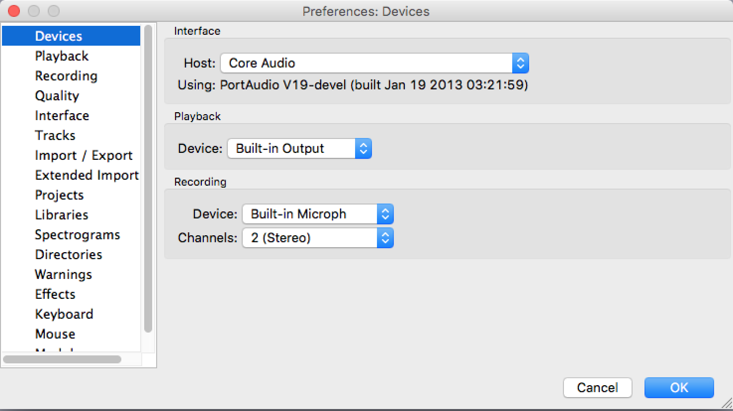
After settings are properly set according to what is required, you can start recording by pushing down the recording button and talk to the mic.
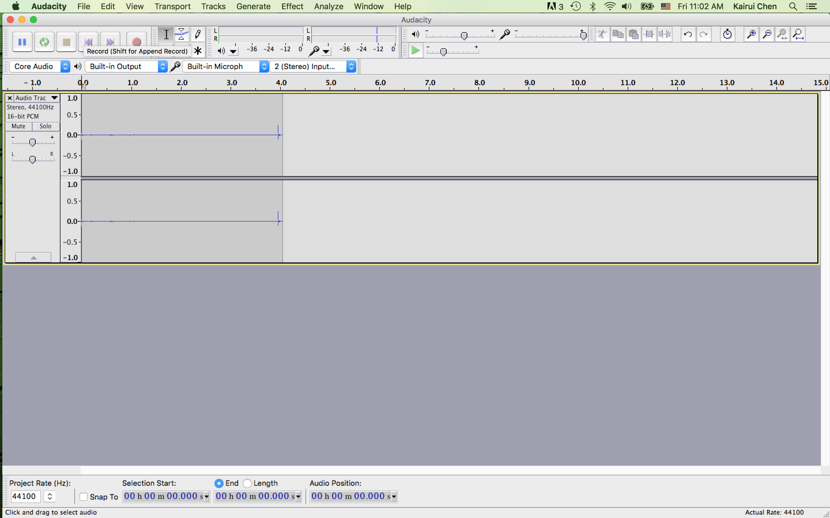
To export your project into a wav file or another format, go to file->export and follow on screen instructions.
Now take the 4th file you exported, use audacity to bleep out the words at 5th second time mark and 10th second time mark. Export it and post it here.
To bleep out a small duration of sound, highlight the segment of sound, go to generate->tone:
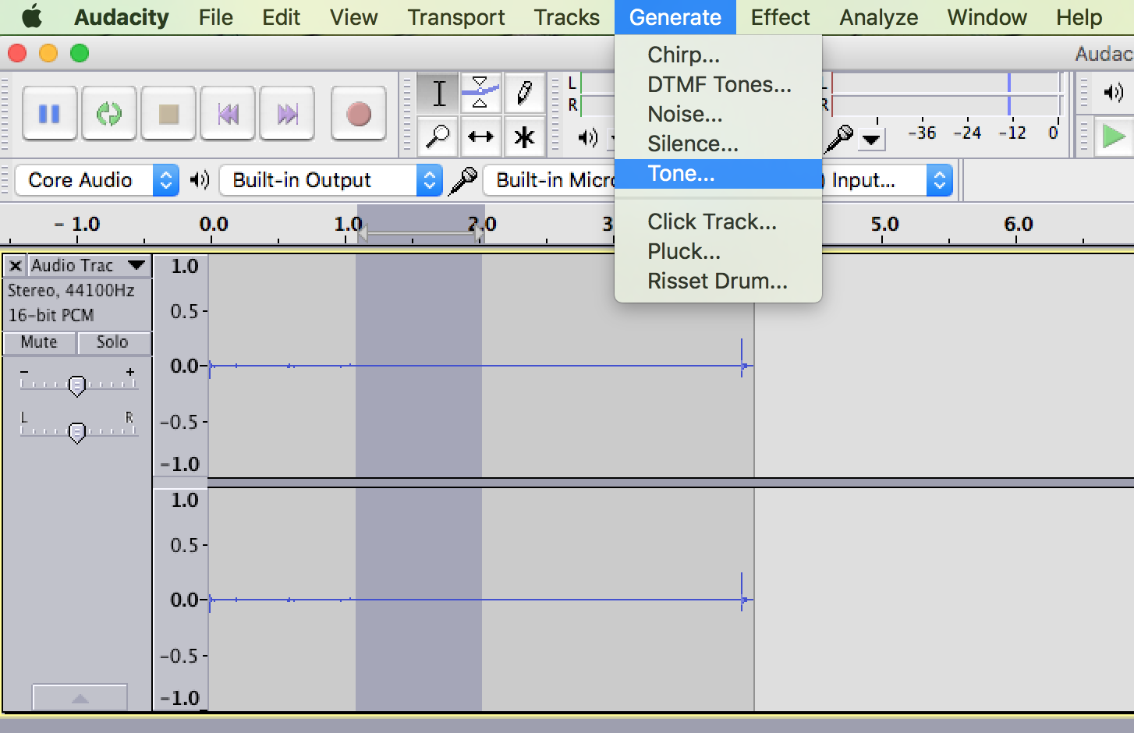
In the Tone Generator dialogue interface, you can change up or down the frequency number (say from default 440 to a higher number for high frequency bleep or down for a lower frequency bleep).
